Climate Change Statistics and Indicators Self-Assessment Tool (CISAT)
Introduction
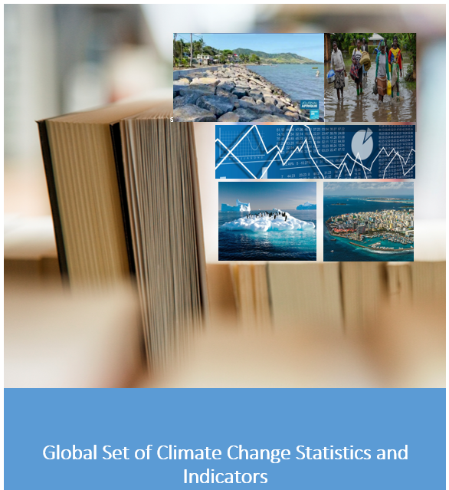

Prepared by the United Nations Statistics Division
31 January 2023
Version 1.0
Introduction
This Climate Change Statistics and Indicators Self-Assessment Tool (CISAT) gives United Nations Member States an opportunity to undertake a thorough and detailed assessment of the statistics and indicators in the Global Set of Climate Change Statistics and Indicators (Global Set). The United Nations Statistical Commission, at its fifty-third session in 2022, adopted the Global Set of Climate Change Statistics and Indicators as the framework for climate change statistics and indicators to be used by countries when preparing their own sets. Similar to the Basic Set of Environment Statistics in the Framework for the Development of Environment Statistics (FDES), the Global Set is comprehensive, but not exhaustive, and designed to support countries according to their individual needs, concerns, priorities and resources.
The Global Set serves as the statistical framework for monitoring and reporting climate action with suitable indicators to serve as a guidance for countries to prepare their own sets. It covers the five policy areas of the IPCC, drivers, impacts, vulnerability, mitigation and adaptation which are broken down into 34 topics. In each area, the most important indicators to describe the topics are listed, thus providing guidance to countries developing national climate change statistics programmes in a comprehensive and balanced manner. Also included are statistics for which distinct methodology was identified. In this way, the Global Set contains 158 indicators and 190 statistics. The purpose of this structure is to ensure balanced coverage of indicators and statistics, and to provide direction to policies (e.g., on drivers, mitigation, adaptation, etc.). In addition, the structure is designed to help countries to select and prioritize the statistics and indicators most relevant to their national context.
The list of indicators and statistics included in the Global Set, as well as the Metadata are best accessed from Part II of the CISAT. The list of indicators can also be accessed in Annex II of the Report of the Secretary-General on Climate Change Statistics to the fifty-third session of the Statistical Commission, pages 15-21.
https://unstats.un.org/unsd/statcom/53rd-session/documents/2022-17-ClimateChangeStats-E.pdf
The decision of the fifty-third Session of the Statistical Commission is referenced in the Final report: decision 53/116 Climate Change Statistics, pages 23-24.
https://unstats.un.org/unsd/statcom/53rd-session/documents/2022-41-FinalReport-E.pdf
The full description of the Global Set and its metadata is included in a Background document to the Report of the Secretary-General, entitled Global Set and metadata: https://unstats.un.org/unsd/statcom/53rd-session/documents/BG-3m-Globalsetandmetadata-E.pdf
The Global Set was developed in close collaboration with the United Nations Framework Convention on Climate Change (UNFCCC) and the Expert Group on Environment Statistics (EGES) and was submitted to a Global Consultation in 2021 to which 86 countries and 26 agencies responded. The consultation consisted of two parts, Part I addressing the institutional dimensions of developing climate change statistics and Part II addressing the individual indicators and statistics. The second Background document to the Report of the Secretary-General on Climate Change Statistics entitled Global Consultation on the Global Set (https://unstats.un.org/unsd/statcom/53rd-session/documents/BG-3m-GlobalConsultationontheGlobalSet-E.pdf) presents a comprehensive summary of the consultation process and its outcomes.
Throughout the 2010s and 2020s, the Environment Statistics Section has observed many United Nations Member States advance their efforts in the fields of environment and climate change statistics. Some of the results of such efforts (typically an Environment Statistics Compendium or similar publication) are collected by UNSD and made publicly available at: https://unstats.un.org/unsd/envstats/fdescompendia.cshtml and climate change statistics reports are available at: https://unstats.un.org/unsd/envstats/climatechange_reports.cshtml. Countries are encouraged and welcome to share final reports and compendia with UNSD. Making a final product available on the UNSD webpage is a chance for UNSD to give support to the effort made by countries and for other countries to observe and learn from good practices in compilation of Climate Change Statistics reports and compendia. The Statistical Commission at its forty-seventh session ‘recommended that countries use the Framework for the Development of Environment Statistics (FDES 2013) to guide the development of climate change statistics and indicators, given the close interrelationship between environment statistics and climate change statistics’.
As the 2022 mandate from the Statistical Commission demands further effort in climate change statistics and indicators from United Nations Member States, it is envisioned that by using the CISAT, Member States may make efforts toward publishing their own compendia or similar publications with a focus on climate change statistics and indicators. This CISAT was prepared by building on the experience of countries applying the FDES Environment Statistics Self-Assessment Tool (ESSAT) (https://unstats.un.org/unsd/envstats/fdes/essat.cshtml) and the Global Consultation on the draft Global Set (Part I and Part II). The country submission to the Global Consultation can be updated and further developed by the countries which had already completed the consultation in 2021. While Part I is kept identical as in the Global Consultation, Part II has been expanded by introducing the self-assessment questions from the ESSAT; however, the changes and modifications were kept to a minimum as to retain consistency and facilitate reuse of previous work.

Structure
This Self-Assessment Tool consists of two parts, Part I: Institutional Dimensions of Climate Change Statistics and Part II: Statistics and Indicators Assessment. Parts I and II are closely related and should ideally not be treated as independent of one another. The metadata for the indicators and statistics are also included in this tool.
Part I: Institutional Dimensions of Climate Change Statistics and Indicators
Part I focuses on the overall institutional and organizational structure of national statistics in the country and on specific information regarding climate change statistics in terms of, inter alia, policy frameworks, mandates, institutional setup, organization, collaboration, resources, international cooperation and uses. Therefore, Part I contains much information which may be of greatest interest from a managerial or policy perspective.
It is divided into the following sections:
- Identification of institutions
- National policies/strategies
- Mandate and organization of climate change statistics
- Production and reporting of climate change statistics
- Inter-institutional collaboration
- Technical assistance and training
- The way forward in climate change statistics

Part II: Statistics and Indicators Assessment
Part II of the CISAT is based on the Global Set and its metadata and consists of three files:
- Instructions for Part II (Word file),
- List of indicators and statistics (Excel file), and
- Metadata (Word file).
The Excel file follows the hierarchical structure of the Global Set (in descending order: area, topic, indicator, statistic) and serves as a tool to assess the national relevance, importance, methodological soundness, data availability and sources of the individual statistics/indicators etc. It also helps to identify relevant quantitative and qualitative data gaps, and to develop a plan for filling them with a view to strengthen climate change statistics according to national priorities, needs and available resources.
The content of Part II is more technical and specific to the field of climate change statistics and would possibly require the involvement of a larger number of stakeholders.

Self-Assessment process
The completion of the Self-Assessment should be undertaken as part of a multi-stakeholder consultation and discussion process on the state of climate change statistics and indicators in the country. Such an initiative, while usually led by the National Statistical Office (NSO), should be carried out as a joint effort by all main relevant stakeholders that play an active role in the production, dissemination and use of climate change statistics and indicators. The Statistical Commission, at its forty-ninth session, reiterated the importance of enhancing collaboration between NSOs and national authorities responsible for reporting climate change related information to UNFCCC. It is therefore encouraged that the NSO consult with both the country’s national focal point to the UNFCCC, as well as broadly with other relevant institutional stakeholders that may include line ministries (e.g., Ministry of Environment, Ministry of Agriculture, Ministry of Energy, Ministry of Water), representatives of academia and non-government organizations, etc, to obtain the necessary information. As such, it is desired that a unified understanding of a country’s situation as pertains to climate change statistics and indicators be realised by all relevant stakeholders to work with this assessment.

The Self-Assessment will provide an understanding of the level of maturity of climate change statistics in the country as well as the efforts needed to advance further in order to support the national climate policy objectives. Please also consult Section 4.2 of the Implementation Guidelines ‘Assessment and implementation of the Global Set’.

Also available in all other official UN languages: - Arabic https://unstats.un.org/unsd/statcom/53rd-session/documents/2022-17-ClimateChangeStats-A.pdf - Chinese https://unstats.un.org/unsd/statcom/53rd-session/documents/2022-17-ClimateChangeStats-C.pdf - French https://unstats.un.org/unsd/statcom/53rd-session/documents/2022-17-ClimateChangeStats-F.pdf - Russian https://unstats.un.org/unsd/statcom/53rd-session/documents/2022-17-ClimateChangeStats-R.pdf - Spanish https://unstats.un.org/unsd/statcom/53rd-session/documents/2022-17-ClimateChangeStats-S.pdf
Also available in all other official UN languages: - Arabic https://unstats.un.org/unsd/statcom/53rd-session/documents/2022-41-FinalReport-A.pdf - Chinese https://unstats.un.org/unsd/statcom/53rd-session/documents/2022-41-FinalReport-C.pdf - French https://unstats.un.org/unsd/statcom/53rd-session/documents/2022-41-FinalReport-F.pdf - Russian https://unstats.un.org/unsd/statcom/53rd-session/documents/2022-41-FinalReport-R.pdf - Spanish https://unstats.un.org/unsd/statcom/53rd-session/documents/2022-41-FinalReport-S.pdf
United Nations Statistical Commission (2016). “Report on the forty-seventh session, Economic and Social Council Official Records, 2016 Supplement No. 4”. Available from https://unstats.un.org/unsd/statcom/47th-session/documents/Report-on-the-47th-session-of-the-statistical-commission-E.pdf (accessed 31 January 2023).
United Nations Statistical Commission (2018). “Report on the forty-ninth session, Economic and Social Council Official Records, 2018 Supplement No. 4”. Available from https://unstats.un.org/unsd/statcom/49th-session/documents/Report-on-the-49th-session-E.pdf (accessed 31 January 2023).
United Nations Framework Convention on Climate Change. National authorities responsible for reporting climate change-related information to the secretariat of the United Nations Framework Convention on Climate Change. Available from https://unfccc.int/process/parties-non-party-stakeholders/parties/national-focal-point (accessed 31 January 2023).

